A.

Letter of Transmittal
June 26, 2026
Dr. Michael Scott, Chief Medical Officer
Dunder Regional Cancer Center (DRCC)
2005 Mifflin Ave
Scranton, PA 18505

Dear Dr. Scott,
Here is my proposal for the Automated Breast Cancer Diagnosis Prediction System, a machine learning tool designed to streamline the diagnostic workflow at DRCC. This project uses a data-driven approach to assist clinical teams by instantly flagging high-risk tumor measurements. By doing this, we can significantly reduce wait times and get patients into treatment much faster.

Right now, DRCC is dealing with a significant workload. A major spike in fine needle aspiration (FNA) biopsy referrals is putting significant pressure on the clinical review team. Reviewing these biopsy measurements manually takes up considerable time, introduces human variability, and creates bottlenecks that delay critical results. To solve this, my project uses a Logistic Regression model trained on the Breast Cancer Wisconsin dataset. It is a highly trusted benchmark from the UCI Machine Learning Repository, comprising 569 patient records and 30 numerical features derived from biopsy images.

I have broken everything down into a comprehensive project plan that covers the problem background, technical data setup, methodology, costs, stakeholder impact, and ethics. All the details are right here, so you can easily review the project and give it the green light.

I am confident that this system will significantly improve diagnostic efficiency and lead to better patient outcomes at DRCC. Thank you for your time and consideration. I look forward to hearing your thoughts and discussing the project further.

Respectfully,

Pam Beesly
Data Scientist / ML Engineer
Dunder Regional Cancer Center

Project Proposal

Automated Breast Cancer Diagnosis Prediction System
Dunder Regional Cancer Center (DRCC) | June 2026

Summary of the Problem
Right now, the team handling fine needle aspiration (FNA) biopsy referrals is dealing with a significant workload. The current setup requires clinical staff to review cell-nucleus measurements from biopsy images manually and determine whether a tumor is malignant or benign.
Because the existing workflow is conducted by manual review, it has created some real operational challenges:
- Long delays: High case volume combined with limited reviewer hours is resulting in a backlog of diagnoses.
- Consistency issues: Sifting through endless rows of metrics can lead to clinical fatigue, which in turn leads to subjective interpretations and inconsistent tagging.
- Zero scalability: As incoming referrals continue to climb, the clinical team simply cannot scale their manual review hours fast enough to keep pace.
Ultimately, the clinic has a strong need for an efficient, data-driven method to manage its ever-growing workload. Automating parts of the pipeline will stabilize classification accuracy, shorten turnaround times, and ensure that high-risk malignant cases are flagged for immediate review and intervention.

Description of How the Data Product Benefits the Customer and Supports Decision-Making
This project introduces an interactive, browser-based tool built in a Google Colab environment to help clinical staff instantly evaluate FNA biopsy metrics. Users can enter tumor metrics and receive a real-time prediction with explicit confidence scores.
This helps clinical decision-making in a few key ways:
- It serves as a reliable, data-driven second opinion, taking some of the cognitive pressure off the review team.
- High-confidence malignant cases are immediately prioritized, allowing doctors to focus on urgent follow-ups.
- The model uses the same logic every time, ensuring consistent, reproducible outcomes no matter how tired a reviewer might be.
- By significantly reducing the time between the initial biopsy and the final diagnostic decision, patients can start necessary treatments much sooner.

Outline of the Data Product – What the Application Actually Looks Like
The final product is a functional Python application running entirely inside Google Colab. The code was broken down into a few distinct layers to keep it clean:
- Data Ingestion: A pandas script pulls the raw CSV data directly from a public GitHub repository.
- Preprocessing: The pipeline cleans the data by mapping the diagnosis target column to binary values and normalizing numerical features using StandardScaler.
- Descriptive Analysis: Three data visualizations were built using matplotlib and seaborn—specifically, a distribution bar chart, a correlation heatmap, and a confusion matrix—to analyze the data.
- Predictive Model: A standard Logistic Regression model from scikit-learn handles the actual training and evaluation.
- Interactive Tool: A user dashboard was built with physical sliders. Clinicians can tweak the tumor dimensions to get an immediate diagnosis prediction with percentage breakdowns.

Description of the Data
This build uses the Breast Cancer Wisconsin (Diagnostic) Dataset from Kaggle and the UCI Machine Learning Repository (Dua & Graff, 2019; UCI Machine Learning, 2016). It contains 569 anonymized patient records, with 30 numerical variables derived from biopsy images. These features examine core cell-nucleus properties, including radius, perimeter, smoothness, and area (Street et al., 1993). Each property is broken down into its mean, standard error, and worst-case value.

The target column is the diagnosis: malignant cases (M) are mapped to 1, and benign cases (B) are mapped to 0. The data is clean, with no missing cells, and is split into 357 benign and 212 malignant samples (Dua & Graff, 2019).

Objectives and Hypotheses
The objectives of this project are:
- Train a Logistic Regression model to classify breast tumors as malignant or benign with at least 92% accuracy on test data.
- Generate three distinct data visualizations to support exploratory data analysis and model evaluation.
- Develop a working, interactive dashboard/prediction tool that enables clinical staff to enter tumor measurements and receive diagnostic predictions in real time.
Hypothesis:
It is hypothesized that when a supervised Logistic Regression model is trained on this dataset, it will meet or exceed a 92% classification accuracy on a test set. This will demonstrate that machine learning models can accurately distinguish between malignant and benign measurements, serving as an effective clinical decision aid and leading to better patient outcomes due to expedited care.

Outline of the Project Methodology (CRISP-DM Lifecycle)
This project is structured around the CRISP-DM (Cross-Industry Standard Process for Data Mining) framework (Wirth & Hipp, 2000). It is a six-phase approach that keeps the development process organized and ensures no important data gets skipped:
- Business Understanding: First, the business problem was identified and defined: classifying FNA biopsy measurements as malignant or benign, with a target accuracy of at least 92% set as the performance benchmark.
- Data Understanding: The Wisconsin dataset was explored to understand feature distributions and confirm the class distribution between benign and malignant cases.
- Data Preparation: The diagnosis column was encoded as a binary target, StandardScaler was applied to normalize the features, and the data was split into 80/20 training and test sets.
- Modeling: A Logistic Regression classifier was trained using scikit-learn (Pedregosa et al., 2011) on the training data.
- Evaluation: The model’s performance was evaluated using the following criteria: accuracy, precision, recall, F1-score, and a confusion matrix on the held-out test set.
- Deployment: The finished notebook was published as a public Google Colab link so evaluators and stakeholders can open and run it directly in their browser.

Funding Requirements
Keeping overhead down is a major focus for this setup, which is achieved by utilizing entirely open-source tools and free cloud infrastructure. The single biggest resource requirement is engineering labor, totaling $1,650 based on an estimated 30 hours at $55 per hour. Beyond that, the actual development and hosting run on Google Colab's free tier, while the dataset is stored at no cost in a public GitHub repository. Because all required libraries—including Python, scikit-learn, pandas, matplotlib, seaborn, and ipywidgets—are open source, the total estimated cost for the entire project stays locked at exactly $1,650.
- Data Scientist / ML Engineer (30 hours × $55/hour): $1,650
- Google Colab (development and hosting): $0
- GitHub (dataset hosting): $0
- All software and libraries: $0 — open source
- Total Estimated Cost: $1,650

Impact of the Solution on Stakeholders
- Radiologists and Oncologists: Reducing the burden of manual review lightens the heavy load of manual documentation and provides a data-driven second opinion to support faster, more consistent diagnostic decisions.
- Patients: Immediately flagging malignant cases expedites referrals for life-saving treatments, which enables better clinical outcomes.
- Administration: Reducing diagnostic bottlenecks increases daily patient throughput, improving efficiency without increasing staffing costs.
- IT Department: The app runs natively in a browser without requiring local server installations, resulting in minimal infrastructure overhead.

Ethical and Legal Considerations
Patient privacy and data ethics were built directly into the design of this project from the very beginning. Because the data comes from publicly available, anonymized research sets on Kaggle and the UCI Machine Learning Repository (Dua & Graff, 2019; UCI Machine Learning, 2016), there are absolutely no names, addresses, or personally identifiable information (PII) included in the files or the model code. Using this type of secondary public data also means the project does not involve direct human subjects research, which exempts it from Institutional Review Board (IRB) review.
From a practical standpoint, this tool has very specific limitations on its use. It is intended solely as a clinical decision aid, providing a helpful second opinion for medical staff rather than a standalone diagnostic tool. A licensed medical professional must review all predictions before any diagnostic or treatment decisions are made. Also, since no machine learning model is 100% perfect, the system displays clear confidence percentages with every result. This setup reminds the user that there is always a margin of error behind the prediction.

Relevant Expertise
The project developer holds a Bachelor of Science in Computer Science from Western Governors University, with coursework covering machine learning, artificial intelligence, data management, and software development. Relevant expertise includes:
- Building supervised machine learning models in Python using scikit-learn.
- Data analysis and visualization using pandas, matplotlib, and seaborn.
- Developing interactive Python tools for non-technical end users.
- Independent study in oncology data management and cancer registry standards, with a long-term professional interest in healthcare IT and diagnostic data workflows.

B.

Executive Summary

Automated Breast Cancer Diagnosis Prediction System
Dunder Regional Cancer Center (DRCC) | June 2026

1. Decision Support Problem
Dunder Regional Cancer Center’s team handling fine needle aspirate (FNA) biopsy referrals is currently facing a significant workload. Currently, the clinic relies entirely on staff manually reviewing cell-nucleus measurements from biopsy images to determine whether a tumor is malignant or benign.
Because the current diagnostic setup is completely manual, it has created three major operational bottlenecks:
- Turnaround delays: High case volume combined with limited reviewer hours means critical diagnoses are backing up.
- Inconsistent outcomes: Sifting through endless rows of data leads to clinical fatigue, resulting in subjective interpretations and inconsistent classifications.
- Zero scalability: As incoming referrals climb month after month, the team cannot scale manual review capacity fast enough to keep pace.
This project directly addresses these challenges by implementing a supervised machine learning model to assist in reviewing biopsy metrics. By using this tool to predict whether a tumor is malignant or benign, this application provides clinical staff with a consistent, data-driven second opinion to help streamline the entire diagnostic workflow, greatly reducing the significant volume of work and resulting in better patient outcomes through more timely treatment.

2. Users and Product Fit
The primary users of this data application are the DRCC radiologists and oncologists who review FNA biopsy results. The secondary customers include the DRCC clinical administrators who are responsible for overseeing diagnostic throughput and reviewing patient outcome metrics.
This tool directly addresses the clinic's operational needs by providing staff with an easy, interactive dashboard that runs in a web browser. Users can simply adjust the tumor measurement sliders to get an instant malignant or benign prediction, along with an explicit breakdown of the confidence percentage. It is important to note that the application is not meant to replace actual clinical judgment. Instead, it serves as a highly consistent, data-driven second opinion to help doctors make faster, more confident diagnostic choices. Additionally, because the entire project runs natively in Google Colab, staff do not need to download or install any software, making it incredibly easy for the clinical team to pick up and start using right away.

3. Existing Gaps
Right now, DRCC lacks an automated system to help review these FNA biopsy metrics. The existing workflow relies entirely on manual tracking, which leaves a few massive gaps in the daily workflow:
- No standard scoring: There is no uniform numerical system for quantifying the likelihood that a tumor is malignant based on measurement data.
- No escalation pipeline: The current setup lacks a built-in mechanism to flag high-priority, high-risk cases for immediate review.
- No feedback loop: Without a centralized data tool, it is almost impossible for the team to review past diagnostic decisions to track trends or double-check for consistency.

4. Available Data
The machine learning model used in this project has been trained on the Breast Cancer Wisconsin (Diagnostic) Dataset, a widely trusted benchmark dataset publicly available on Kaggle and the UCI Machine Learning Repository (Dua & Graff, 2019; UCI Machine Learning, 2016). Because the source data contains no missing values or corrupted rows, the dataset is clean, and the cleanup phase requires minimal preprocessing before the model can begin training. The foundational criteria of the dataset have been structured around the following key parameters:
- The patient count: The files contain anonymized data for exactly 569 patient records.
- What the features track: Under the hood, the dataset monitors 10 distinct cell-nucleus traits from digital biopsy images — including radius, texture, perimeter, area, and smoothness.
- How it gets to 30 variables: Instead of just providing a single number for those 10 traits, each one is broken down into three separate dimensions: the overall mean, the standard error, and the worst-case values recorded across the sample.
- Setting up the target column: For the classification model, the diagnosis column serves as the binary target, with malignant cases mapped to 1 and benign cases to 0.
- The category split: The dataset is split into 357 benign and 212 malignant cases.

5. Methodology
The development process for this application follows the standard CRISP-DM framework (Wirth & Hipp, 2000), which breaks the machine learning lifecycle down into six iterative phases.
- Mapping out the clinical problem: The initial phase focuses on business understanding, which involves defining the core diagnostic bottleneck at the clinic, identifying what stakeholders need from the software, and setting a firm target of hitting at least 92% classification accuracy.
- Digging into the data features: The next phase involves understanding the data. This process entails exploring the Wisconsin dataset and analyzing it using visual plots — critical for assessing feature distributions and the balance between malignant and benign cases before writing any model code.
- Preparing the variables for training: During data preparation, the target diagnosis column is encoded as binary values, with malignant = 1 and benign = 0. From there, StandardScaler is used to normalize the numerical features, and the dataset is split into 80% for training and 20% for testing.
- Building and fitting the model: A Logistic Regression classifier is trained using scikit-learn (Pedregosa et al., 2011) on 80% of the dataset.
- Measuring performance: The evaluation phase involves calculating accuracy, precision, recall, and F1-score, and generating a confusion matrix to assess exactly where the model gets predictions right or wrong.
- Deploying the final application: The final phase involves publishing the completed notebook as a public Google Colab link, making the application instantly accessible to evaluators and clinical staff and allowing anyone to open and run the entire system in a web browser without installing local software.

6. Deliverables
This project delivers the following components as part of the final submission:
- The Primary Notebook Link: The main deliverable is a public Google Colab URL. This notebook contains the entire project pipeline from end to end—including all data cleaning, plotting code, model training, and the final user widget.
- The Data Repository: A public GitHub repository serves as the backend storage layer, hosting the raw data.csv file so the Colab script can load the dataset directly into the notebook.
- Exploratory Data Graphics: The notebook automatically generates three distinct visualizations—specifically, a bar chart showing diagnosis distributions, a feature correlation heatmap, and a final confusion matrix to evaluate model performance.
- The Interactive Dashboard: Built natively with ipywidgets, this dashboard features functional sliders that let users enter custom tumor metrics and watch the model calculate a prediction in real time.
- Model Scorecard: A detailed classification breakdown is generated right in the workspace, displaying the final percentages for accuracy, precision, recall, and F1-score.
- Final Documentation: The complete project paper covers all project requirements, including background context, the hypothesis and outcomes, testing metrics, and a quick start guide for running the code.

7. Implementation Plan and Expected Outcomes
This data application will be implemented in four phases:
- Phase 1 – Data Setup: The raw dataset file was uploaded to a public GitHub repository. From there, the Google Colab environment is configured to load the dataset directly into the notebook via a raw URL.
- Phase 2 – Development: The preprocessing pipeline is built, generating three visualizations, and the Logistic Regression model is trained and evaluated.
- Phase 3 – Interactive Tool: This involves implementing an ipywidgets dashboard with sliders for all 10 mean tumor features and configures the prediction output to display confidence percentages.
- Phase 4 – Deployment and Documentation: The Colab notebook is made public, and all required documentation is completed.
The anticipated outcomes are a Logistic Regression model achieving ≥ 92% classification accuracy, the generation of three production-quality data visualizations, and a fully functional, interactive prediction tool accessible via a web browser with no software downloads or installation required.

8. Validation and Verification
Ensuring that the model works as intended has been a core component of the development process. Several methods were used to verify that the application meets both the technical requirements and real-world use case needs of the clinic:
- Training/Test Split (80/20): The dataset was divided into two categories. The model is trained on 80% of the data, and the remaining 20% is used for testing. This allows for an unbiased assessment of how the model analyzes new, unseen cases.
- Classification Report: After running predictions on the test set, the classification report from scikit-learn reported the accuracy, precision, recall, and F1-score for both the malignant and benign classes. This report ensures the model not only performs well overall but is also accurate across both categories.
- Confusion Matrix: A visual confusion matrix was generated to identify where the model correctly predicted and where it did not. This ensures that true positives, true negatives, false positives, and false negatives can be identified immediately.
- Hypothesis Check: The model’s final accuracy was compared against the declared hypothesis threshold of ≥ 92%. The model surpassed the hypothesis threshold, achieving 96% accuracy on the test set, which means the original hypothesis can be formally accepted and verified.
- Interactive Tool Testing: The prediction dashboard underwent manual testing using known malignant and benign cases from the dataset to confirm that the sliders and the resulting output display work correctly from end to end.

9. Programming Environments and Costs
Resource | Description | Cost
Python 3 | Primary programming language | $0 (open source)
Google Colab | Development environment and hosting platform | $0 (free tier)
GitHub | Dataset hosting (CSV file) | $0 (free tier)
scikit-learn, pandas, matplotlib, seaborn, ipywidgets | ML, data analysis, visualization, and UI libraries | $0 (open source)
Data Scientist / ML Engineer | 30 hours × $55/hour | $1,650
TOTAL |  | $1,650

10. Projected Timeline
Milestone | Start Date | End Date | Duration | Resources / Dependencies
Data setup and GitHub upload | June 13, 2026 | June 13, 2026 | 1 day | Kaggle dataset download complete
Preprocessing and EDA | June 14, 2026 | June 16, 2026 | 3 days | Data setup complete
Model training and evaluation | June 17, 2026 | June 19, 2026 | 3 days | Preprocessing complete
Interactive dashboard development | June 20, 2026 | June 23, 2026 | 4 days | Model training complete
Documentation and write-up | June 24, 2026 | June 27, 2026 | 4 days | All development complete
Final review and submission | June 28, 2026 | June 29, 2026 | 2 days | Documentation complete

C.
The fully functional data product for this project is the Google Colab notebook attached to this submission. The public link is also available at:
https://colab.research.google.com/drive/1W56HKJuNUWURp06_HWcJE7Vl98gt3CqI?usp=sharing

D.

Documentation

D1. Business Vision and Requirements Document
Project Title: Automated Breast Cancer Diagnosis Prediction System
Organization: Dunder Regional Cancer Center (DRCC)
Date: June 2026
Business Vision:
This application is designed to clear diagnostic backups at the clinic and improve the predictability of how biopsy metrics are scored. It introduces a live machine learning tool that evaluates fine needle aspirate metrics on the spot to predict whether a tumor is benign or malignant. Moving to this automated approach lets the medical staff immediately identify urgent cases, reducing patient wait times and referring patients to earlier clinical care to ensure the best health outcomes.
Business Requirements:
The application needs to reach the following benchmarks to be considered production-ready:
- Accepts 10 core tumor measurements as user inputs
- Returns a binary prediction (Malignant or Benign) with a confidence percentage
- Achieves at least 92% classification accuracy on the test dataset
- Runs entirely in a web browser — no software installation needed
- Does not store, transmit, or display any personally identifiable patient information. Industry-standard security is maintained using fully anonymized public data, with no PII stored or transmitted at any point in the pipeline.
- Includes at least three data visualizations for exploratory analysis and evaluation of the model
- Clicking the Predict button feeds the current slider values into the trained model and immediately returns a malignant or benign classification along with confidence percentages. No page reloads happen, and no external APIs are called.
Functional Requirements:
- Load the dataset from a GitHub-hosted CSV using pandas
- Encode the binary target and scale features with StandardScaler
- Train a Logistic Regression model on 80% of the dataset using the scikit-learn platform
- Evaluate performance on the remaining 20% of data by using accuracy, precision, recall, and F1-score as the measurement criteria
- Generate three visualizations: diagnosis distribution bar chart, correlation heatmap, and confusion matrix
- Provide an ipywidgets dashboard for real-time tumor measurement input and prediction output
Non-Functional Requirements:
- Platform: Google Colab (browser-based, OS-independent)
- Language: Python 3
- All cells must be executable in sequence from top to bottom.
- The interactive tool must respond to input instantly without page reloads or external API calls.

D2. Datasets and Code
Raw Dataset:
The project uses the Breast Cancer Wisconsin (Diagnostic) Dataset pulled from Kaggle and the UCI Machine Learning Repository (Dua & Graff, 2019; UCI Machine Learning, 2016). The raw data.csv file contains 569 rows and 32 columns: one ID column, one diagnosis column, and 30 numerical features. The file is hosted on GitHub and is loaded directly into the notebook using pandas.read_csv().
Data Cleaning Steps Applied:
- Dropped the id column, which has no predictive value
- Dropped Unnamed: 32, which is an empty artifact column that appears in the raw CSV file
- Encoded the diagnosis column: M (Malignant) converted to 1, B (Benign) converted to 0
- Applied StandardScaler to all 30 of the feature columns to normalize the value ranges for Logistic Regression
None of the rows were removed. Additionally, the dataset contains no missing values.
Source Code Location:
All the source code resides in the submitted Google Colab Notebook. It is organized into labeled cells with imports, data loading, preprocessing, visualizations, model training, and the interactive slider tool. The public Colab link contains both the project's source code and the executable. The public Colab link is: https://colab.research.google.com/drive/1W56HKJuNUWURp06_HWcJE7Vl98gt3CqI?usp=sharing

D3. Code Used to Perform the Analysis
Descriptive Analysis:
Three visualizations were built using matplotlib and seaborn to explore the dataset before any model training began. The first is a bar chart showing how the diagnosis cases are split between malignant and benign. The second is a correlation heatmap that maps out the relationships between the 10 core mean tumor features and the diagnosis outcome. Running these visuals first helps build a clearer picture of the data before the model is introduced.
Predictive Analysis:
The prediction model uses scikit-learn's LogisticRegression class (Pedregosa et al., 2011) with max_iter=10000 to make sure the optimizer fully converges. Prior to training, StandardScaler is used to normalize the feature values, but it is only fitted on the training data and is then applied to the test set separately. This process prevents any test data from influencing the training process. The dataset is split 80/20, preserving the original proportions of malignant and benign cases in both subsets, with random_state=42 to ensure consistent, reproducible results.
Evaluation Code:
Model performance is tracked using four criteria from the sklearn.metrics: accuracy_score, classification_report, confusion_matrix, and ConfusionMatrixDisplay. The confusion matrix is also rendered as the third data visualization in the notebook.
Interactive Tool Code:
The prediction dashboard uses ipywidgets FloatSlider widgets for each of the 10 mean tumor features. When the Predict button is clicked, the function fills in the remaining 20 columns using dataset medians, scales the full input using the trained StandardScaler, and runs it through model.predict() and model.predict_proba(). The result is displayed as color-coded HTML — green for benign and red for malignant — with confidence percentages shown alongside the prediction.

D4. Assessment of Hypothesis
Stated Hypothesis
This project has been built with the intention that training a Supervised Logistic Regression Model on the Wisconsin Dataset will result in at least 92% classification accuracy on a held-out test dataset. Achieving this benchmark demonstrates that machine learning algorithms can be relied upon to accurately categorize malignant and benign measurements, making the application a valuable tool for reducing the backlog of work and enabling more expedient clinical decision-making, resulting in faster treatment times for urgent cases.
Result
When the Logistic Regression model was evaluated on the held-out test set, which comprised 20% of the overall dataset, the model achieved a final accuracy of 96%, exceeding the original 92% project hypothesis. In addition to exceeding the hypothesized accuracy of 92%, the model also demonstrates that the underlying precision, recall, and F1-score remained high across the malignant and benign tumor categories, indicating that it was not heavily biased toward predicting only one class.
Hypothesis Decision
The hypothesis decision is accepted because the model successfully achieved and exceeded the established accuracy benchmark of 92%. The 96% accuracy rating demonstrates that the Logistic Regression classifier correctly separated malignant and benign cases in this dataset. The exact percentages for final accuracy, precision, recall, and F1-score are detailed in the classification report within the program runtime environment.
A Note on False Negatives
From the perspective of a medical workflow review, a false negative error (in which the algorithm predicts a case as benign when the tumor is malignant) is a far worse outcome than generating a false positive. To assist clinicians in evaluating this specific trade-off, a visual confusion matrix is generated directly within the user workspace. It is critical to emphasize that this software is intended solely as a decision-making support tool, not as an automated medical authority. Since the model inherently possesses a slight margin for error, a licensed medical professional must always thoroughly review the final predictions before making any diagnostic decisions or referring patients to treatment options.

D5. Visualizations
Three visualizations were produced to support data exploration, model evaluation, and storytelling about the breast cancer diagnostic classification problem. Screenshots of each visualization are included below.
Visualization 1: Diagnosis Distribution Bar Chart
This visualization (pictured below) shows the class balance of the dataset, which comprises 357 benign cases (63%) and 212 malignant cases (37%). This visualization creates a baseline class distribution and confirms that the dataset is moderately imbalanced, which is noted as context for interpreting the model's performance metrics.
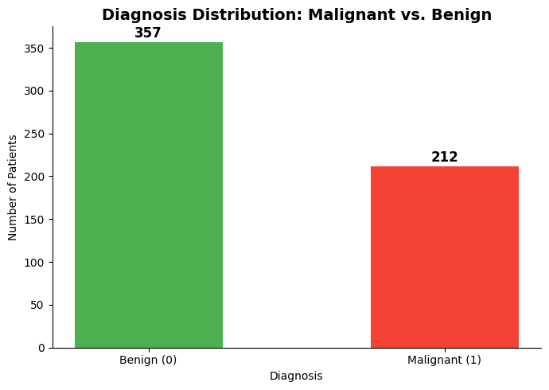

Visualization 2: Feature Correlation Heatmap
This visualization (pictured below) shows the correlation matrix for the 10 core mean tumor features and the diagnosis result. Specific features, such as radius_mean, perimeter_mean, and area_mean, show stronger correlations with malignant diagnoses in this dataset. The fractal_dimension_mean shows minimal correlation, suggesting a lower predictive value for tumor outcomes.
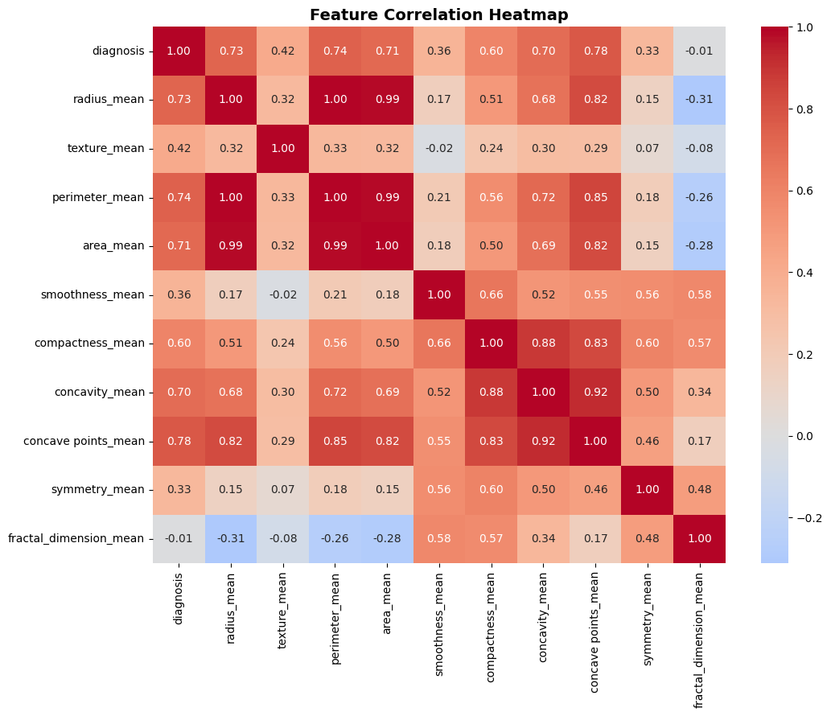

Visualization 3: Confusion Matrix
This visualization (pictured below) shows the model's prediction outcomes on the test set across four different categories: true positives (tumors are correctly predicted as malignant), true negatives (tumors are correctly predicted as benign), false positives (tumors are predicted as malignant when they are benign), and false negatives (tumors are predicted as benign when they are actually malignant). Additionally, the matrix shows 71 true negatives and 1 false positive across 72 total benign cases, and 39 true positives and 3 false negatives across 42 total malignant cases, for a combined test set of 114 patients. These results align directly with the classification report support counts and the 96% overall accuracy reported in D6.
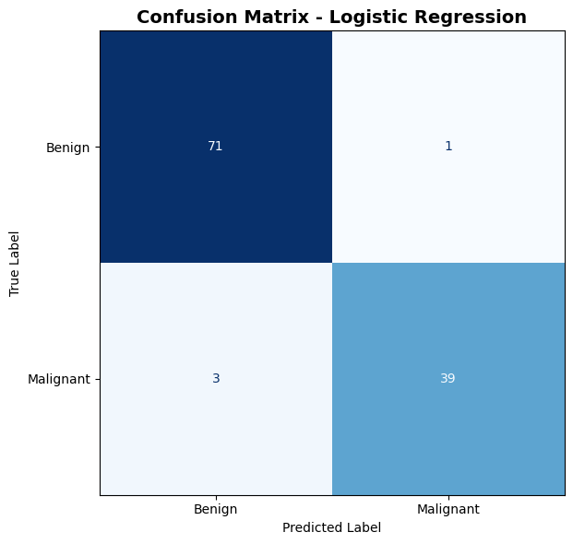

D6. Assessment of Product Accuracy
The model accuracy was assessed on the held-out 20% test dataset (comprised of 114 patients) and using four metrics:
Metric | Definition | Result
Accuracy | Overall correct predictions / total predictions | 96%
Precision (Benign) | Proportion of all cases predicted to be benign that were benign | 0.96
Precision (Malignant) | Proportion of all cases predicted to be malignant that were malignant | 0.97
Recall (Benign) | Proportion of actual benign cases correctly identified as benign | 0.99
Recall (Malignant) | Proportion of actual malignant cases correctly identified as malignant | 0.93
F1-Score (Benign) | Harmonic mean of precision and recall | 0.97
F1-Score (Malignant) | Harmonic mean of precision and recall | 0.95

The stated hypothesis threshold of ≥ 92% was met and exceeded with ≥ 96% accuracy. The precision, recall, and F1-score metrics remained high across both classes, confirming that the model is balanced rather than biased toward a single outcome. The complete classification report is available in the Colab notebook output and in the screenshot below.
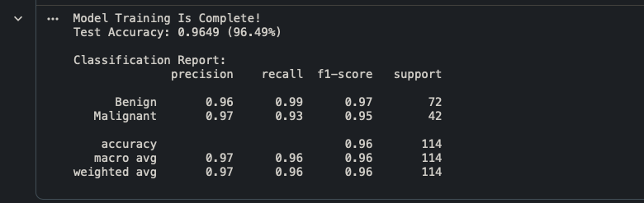

D7. Testing Results, Revisions, and Optimization
Initial Testing:
The notebook was tested end-to-end by clicking Runtime → Run All in Google Colab. Everything ran cleanly without errors — the dataset loaded from the GitHub URL on the first try, and all the downstream steps from preprocessing through model evaluation finished exactly as expected.
Interactive Tool Testing:
The prediction dashboard was tested using real measurement values from known cases in the dataset. Sliding the inputs toward high-risk tumor profiles yielded high-confidence malignant predictions, and known benign profiles returned high-confidence benign results—the color-coded output — red for malignant, green for benign — rendered correctly in both cases.
Revisions Made:
- max_iter was increased from the default 100 to 10,000 to give the optimizer enough time to fully converge on the scaled features.
- StandardScaler was fitted on training data only to keep the test set isolated and prevent data leakage from affecting the final scores.
The interactive tool was updated to automatically fill in dataset median values for the 20 SE and worst-value columns not included in the sliders, keeping the full 30-feature input shape intact for the scaler and model.
Keeping the model healthy and accurate in the long term is straightforward. As new biopsy data come in, the model should be periodically retrained to prevent it from drifting out of alignment with current patient data. Monitoring accuracy is as simple as re-running the evaluation cell in the notebook and checking the result against the original 96% benchmark. If accuracy dips below the 92% project threshold, that is the signal to retrain on the updated dataset before putting it back into use. Since the notebook runs sequentially from top to bottom, any stakeholder with Colab access can run a full re-evaluation in under two minutes.
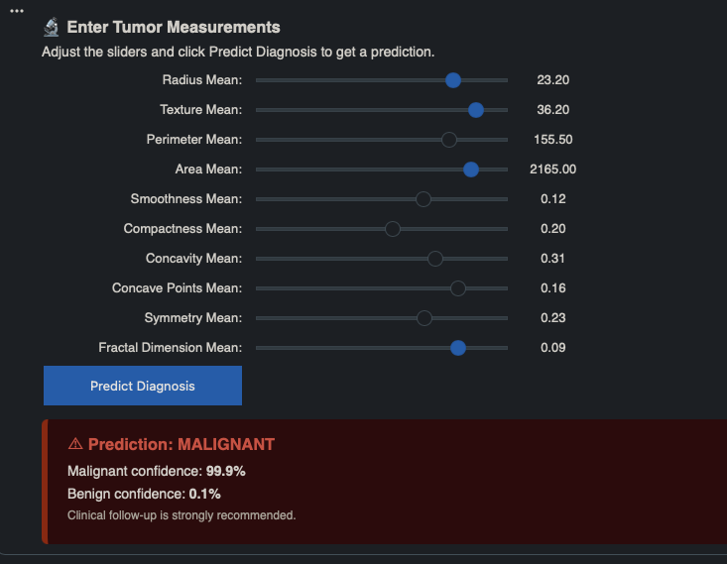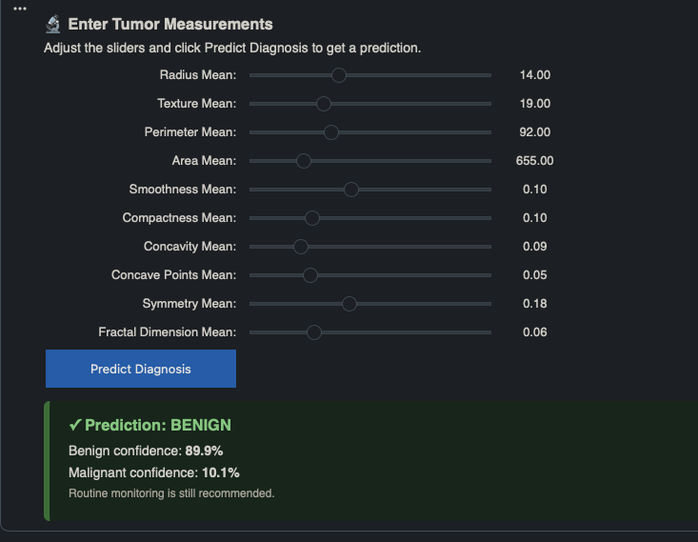
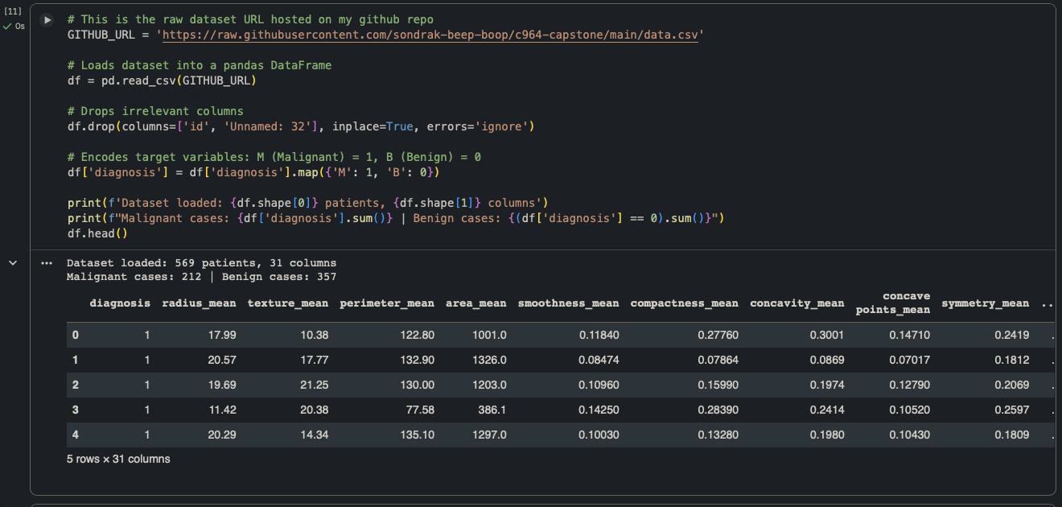

D8. Source Code and Executable File
This whole project runs out of a single Google Colab notebook link, which serves as both the code repository and the live application. It is completely open to the public via the URL below, meaning anyone can test it out on the spot without installing local software.
Public Colab Link: https://colab.research.google.com/drive/1W56HKJuNUWURp06_HWcJE7Vl98gt3CqI?usp=sharing
GitHub Dataset Repository:
https://raw.githubusercontent.com/sondrak-beep-boop/c964-capstone/main/data.csv

D9. Quick-Start Guide
Automated Breast Cancer Diagnosis Prediction System
Dunder Regional Cancer Center (DRCC) | User Quick-Start Guide
This tool analyzes fine needle aspirate (FNA) biopsy tumor measurements and predicts whether a tumor is Malignant or Benign using a trained Logistic Regression model. It runs entirely in your web browser with no software installation required.
System Requirements:
  - A modern web browser (Chrome, Firefox, Edge, or Safari)
  - A Google account (free) (this is required to run the notebook)
  - Internet connection
Steps to Run the Notebook:
- Open the following link in your browser:
https://colab.research.google.com/drive/1W56HKJuNUWURp06_HWcJE7Vl98gt3CqI?usp=sharing
- Sign in to your Google account, if prompted.
- Click Runtime in the top menu bar.
- Click Run all from the dropdown menu.
- Wait approximately 30–60 seconds for all cells to finish executing. A checkmark will appear to the left of each completed cell.
- Scroll to the bottom of the notebook to find the Interactive Prediction Tool.
How to Use the Interactive Prediction Tool:
- Adjust the sliders to enter tumor measurements for a patient case.
- Click the blue Predict Diagnosis button.
- The result will appear below the button:
- A green box indicates a Benign prediction with a confidence percentage.
- A red box indicates a Malignant prediction with a confidence percentage.
Slider Reference – What Each Measurement Means:
Feature | Description
Radius Mean | Mean distance from tumor center to perimeter points
Texture Mean | Standard deviation of gray-scale values in the image
Perimeter Mean | Mean size of the tumor perimeter
Area Mean | Mean area of the tumor
Smoothness Mean | Local variation in radius lengths
Compactness Mean | Perimeter² / area − 1.0
Concavity Mean | Severity of concave portions of the tumor contour
Concave Points Mean | Number of concave portions of the tumor contour
Symmetry Mean | Symmetry of the cell nucleus shape
Fractal Dimension Mean | Complexity of the tumor boundary (coastline approximation)

Important Disclaimer:
This tool is intended for educational and clinical decision support purposes only. A licensed medical professional MUST review any predictions produced by this tool before any diagnostic or treatment decisions are made.


E. Sources
References
Dua, D., & Graff, C. (2019). Breast Cancer Wisconsin (Diagnostic) data set. UCI Machine Learning Repository. https://archive.ics.uci.edu/ml/datasets/Breast+Cancer+Wisconsin+(Diagnostic)
UCI Machine Learning. (2016). Breast Cancer Wisconsin (Diagnostic) data set [Data set]. Kaggle. https://www.kaggle.com/datasets/uciml/breast-cancer-wisconsin-data
Street, W. N., Wolberg, W. H., & Mangasarian, O. L. (1993). Nuclear feature extraction for breast tumor diagnosis. IS&T/SPIE 1993 International Symposium on Electronic Imaging: Science and Technology, 1905, 861–870. https://doi.org/10.1117/12.148698
Pedregosa, F., Varoquaux, G., Gramfort, A., Michel, V., Thirion, B., Grisel, O., Blondel, M., Prettenhofer, P., Weiss, R., Dubourg, V., Vanderplas, J., Passos, A., Cournapeau, D., Brucher, M., Perrot, M., & Duchesnay, E. (2011). Scikit-learn: Machine learning in Python. Journal of Machine Learning Research, 12, 2825–2830. https://jmlr.org/papers/v12/pedregosa11a.html
Wirth, R., & Hipp, J. (2000). CRISP-DM: Towards a standard process model for data mining. Proceedings of the Fourth International Conference on the Practical Application of Knowledge Discovery and Data Mining, 1, 29–39. https://www.cs.bris.ac.uk/~flach/papers/crispdm.pdf

